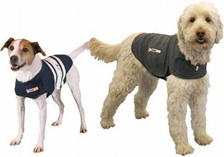

**Noise fearful dogs and anxious dogs can have trouble this time of year. We have lots of options to help them!**

**- DAP collars: pheromones that release over a month to calm without side effects  
- Thundershirts: vest that holds tight around dogs that like to be held or in small places when afraid.   
- Medications: Numerous anti-anxiety medications exist, we can find one that works for a very anxious pet!**

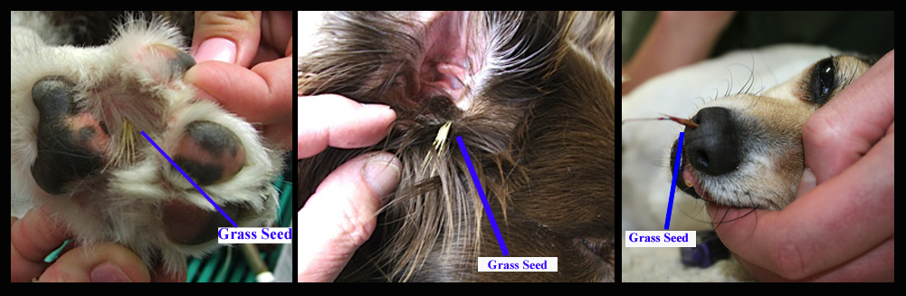

**Grass Seeds**These are expertly designed to dig themselves into dirt…or anything else they find within minutes!   
The most common places these seeds get embedded are feet and ears. Both locations can be very painful. The seeds will continue to move down and can cause severe infections if they travel too far. Sedation is often required to remove them completely and safely.   
Typically late summer or early fall is the most common time, but with all of our grass from this spring we are seeing them early.   
TIPS:  
- No off leash runs in tall grass  
- Brush immediately after walks near tall grass  
- Bring in ASAP if you think your pet has these seeds in ears or skin.

**Summer brings warm temperatures, outside activities, fireworks and thunderstorms. We want all of these to be fun and safe for everyone!**

July Newsletter